Directions to Gatlinburg Memories’ Condo Locations

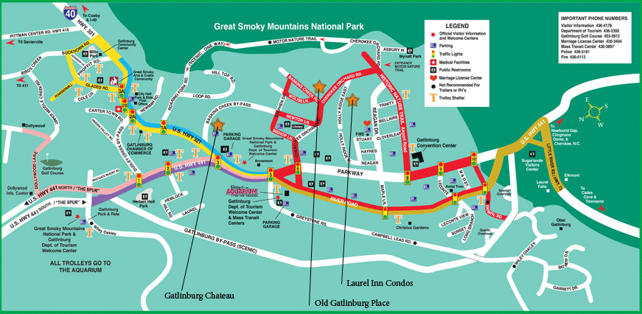
***The stars are the locations of our available condos***
Directions from Pigeon Forge
Gatlinburg Chateau Condos
Going into Gatlinburg, turn left at Stop Light #3 (all stop lights have a green sign with a # posted), East Parkway or Hwy 321, go one block up. Then turn right on Baskins Creek By-Pass then immediately right into the driveway of Gatlinburg Chateau Condos. Go up the driveway to the upper parking lot. Carts to unload and an elevator are located in the center of the building.
Olde Gatlinburg Place
Going into Gatlinburg, turn left at Stop Light #6 (all stop lights have a green sign with a # posted), Cherokee Orchard, go up 1-1/2 blocks, turn left on Baskins Creek Road. Olde Gatlinburg Place Condos is on the right corner. Go past building, turn right behind building. Parking, elevators, and carts are located in the rear of the building.
Laurel Inn Condos
Going into Gatlinburg, turn left at Stop Light #6 (all stop lights have a green sign with a # posted), Cherokee Orchard, go up 2-1/2 blocks, turn right on Holly Ridge. Up the lane, Laurel Inn Condos is located on the left.

